national Research Network



รองศาสตราจารย์ ดร. ภัคพล ปรีชาศิลป์
Assoc. Prof. Dr. Pakkapon Preechasilp
pibulsongkram rajabhat university



Dr. Vipavee Damminsed
Faculty of Science at Sriracha Kasetsart University


NUTT TANANIMIT
DEPARTMENT OF MATHEMATICS EDUCATION, WALAILAK UNIVERSITY, NAKHON SI THAMMARAT, THAILAND Email address: nutt.ta@wu.ac.th

THANATPORN GRACE
DEPARTMENT OF MATHEMATICS EDUCATION, WALAILAK UNIVERSITY, NAKHON SI THAMMARAT, THAILAND Email address: thanatporn.gr@wu


Panatda Boonman
Mathematics, Faculty of Science and Technology, Rajamangala University of Technology Suvarnabhumi
panatdaw@hotmail.com

International Research Network
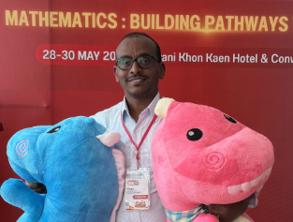
YIRGA ABEBE BELAY
DEPARTMENT OF MATHEMATICS, AKSUM UNIVERSITY, AKSUM, ETHIOPIA
Email address: yirga2006@gmail.com

